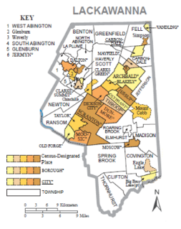United Neighborhood Centers

777 Keystone Industrial Park Rd.

Throop, PA 18512

570-346-0759

**Homeless Management Information System Grievance Form**

Name of Individual Filing the Grievance:

Name of Homeless Management Information System Agency:

**Grievance Information**

Date of Occurrence:

Have you discussed with HMIS Agency? □ yes □ no

Date(s) of Discussion:

Issue of Grievance:

List specific problem(s)/issue(s):

For clarification of the issues of your grievance, please provide statements regarding the condition which is the subject of this grievance. (Describe what happened, when and where. Attach any supporting documentation.)

Relief Requested: Indicate the action(s) that would resolve your grievance.

My signature indicates that the information contained on this form and attachments to this form are true and factual to the best of my knowledge.

Date Signature